Fourth Sunday of Easter  Reading I: Acts 4:8-12  Responsorial Psalm: 118:1, 8-9, 21-23, 26, 28, 29  Reading II: 1 John 3:1-2  Gospel: John 10:11-18  Readings may be found on the US Bishop’s website:  https://bible.usccb.org/bible/readings/042124.cfm | 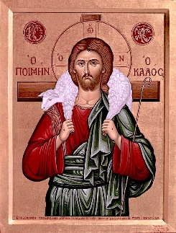

In the passage from Acts, there is another sermon by Peter. It is about the same healing of the man at the temple as the passage last week. In between, Peter and John were arrested by the Jewish leaders and brought before the high priest. They were then questioned: “By what power or by what name have you done this?” Peter’s reply is presented in our reading.
Two points are to be noted. First is again the “no-yes” regarding Jesus. The Jewish leadership had crucified Jesus, but God raised him from the dead. You judged him wrongly, and you should reexamine your position. The same can be addressed to any person who does not accept Jesus. The uniqueness of the resurrection should be such an overwhelming truth that all who are not believers should reexamine their belief.
Secondly, the connection of Psalm 118:22 to Jesus: “He is ‘the stone rejected by you, the builders, which has become the cornerstone.” Those who were overseeing the people of God rejected Jesus, but God has made Jesus the central person in the new work that God is doing in establishing the church. Religious leaders should reexamine the direction that they are showing others for Christ is the new beginning.
Peter finally proclaims, “There is no salvation through anyone else, nor is there any other name under heaven given to the human race by which we are to be saved.”
This sets the pathway for the human race. We come to see the death and resurrection of Jesus as how God has reunited the human race with the divine – through faithful enduring love, even through death on the cross. At the same time, God is not bound by this but is free to work in the hearts and lives of people as God chooses. So, Jesus has other sheep that Jesus desires to lead into the one flock.

The First Letter of John enters a new focus in our reading for this Sunday with God’s love for humanity, as shown in the death of resurrection of Jesus being central. Jesus introduced the disciples to addressing God, "Father." One aspect of this is a title that expresses endearment and connection. God is not simply a distant being, but God is one whom we can call upon and with whom we can talk. Jesus used the familial form of Father, "Abba." The first words that a child learns are Imma and Abba. It is with a familial connection that we are to connect with God. The other aspect is that in being a Father, God cares for us and is interested in our lives, our joys, and our struggles. God desires our good and wants to be part of our life. One does not need to convince God or earn God's attention. We are each a child of God, just like Jesus, and our final destiny is the same as Jesus’ destiny. We are moving toward sharing life with God for eternity.
While Jesus was living, he suffered rejection, ridicule, and physical pain. Human society continues to find the Christian life unreasonable. The call to love one’s enemies, forgive those who injure you, and care for the hungry, naked, imprisoned, or strangers are opposed on economic, nationalistic, or cultural grounds. Those who promote the demands of the Gospel face opposition, ridicule, and occasional threats.
Our fate will match that of Jesus. We may experience loss and suffering as we follow the Christian path. There are no guarantees that life will be easy, that everything will go well, or that we will be comfortable. The assurance that we have is that God will be with us and never abandon us. Like Jesus, we will rise and live in the fullness of life with God and all the others who are alive in Christ. When Christ returns, the true value of the gospel values, of sacrificial love, of being a disciple will be revealed.

One of the earliest and most common depictions of Jesus was as the Good Shepherd. This image is from the second century showing Jesus with the lamb on his shoulders and the flock gathering around him. There was a long tradition in the Old Testament in presenting God as the shepherd of Israel. (Psalm 23, Ezekiel 34, Jeremiah 23) The leaders whom God sent were to be good shepherds of God’s chosen people. (Moses, David, and the anointed kings) Often they failed. | 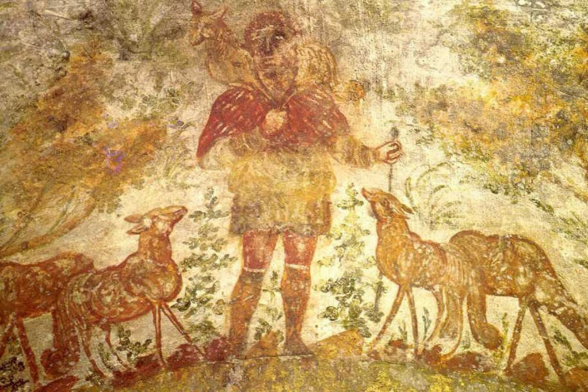
Jesus presents himself as the Good Shepherd. (The word good can be translated as true or authentic.) As a shepherd, Jesus lays down his life for those entrusted to his care. (Not like those who care for the sheep for their advantage) This self-sacrificing love is oriented to the benefit of the sheep so that they may have life. The shepherd also knows his sheep, and the sheep know him. The Shepherd is with them, and there is a connection, a relationship. As sheep, we must come to know the shepherd and allow Jesus to connect with us. He is available, and we must act amid the busyness and plans to accept the offer and come to know the shepherd.
Here the reference to other sheep is found. Initially, it may be referring to the Gentiles, all the non-Jewish people of the world who did not know the one God. It continues to challenge us to share the Gospel message through our words, deeds, and very lives. As disciples, we can introduce our society to a new goal in life. It is not money, fame, or power but a relationship with God.

Themes:
Christian Leadership Images and Names of God
Christ’s Universal Mission Relationship with God

Reflection Questions:
What impact does the resurrection have on you?

Have you experienced being accused of or being judged wrongly? What happened?
What is the connection between love and sacrifice?

What does “being like him” mean to you?

What images or names of Jesus are significant for you? Why?

What are examples of self-sacrificing love that you have known? For what do people give their lives?

How has Jesus or God shepherded you?

Prayer Suggestions:
For the Church: that the Holy Spirit will guide us in distinguishing the voice of the Good Shepherd from all the other messages and help us to respond to all of Christ's invitations faithfully
For a spirit of openness: that we may allow the saving work of Jesus to heal us and bring us to wholeness so that the power of the resurrection may be manifest to all the human family
For all who minister in the Church: that they may draw strength and inspiration from the Good Shepherd, model in word and deed Christ’s dedication to the children of God, and serve their communities with the heart of the Good Shepherd
For all who are laying down their lives in caring for sick children, the developmentally disabled, the elderly, or the terminally ill: that God will renew them and fill them with energy and love
For all who are searching for direction in life: that the Good Shepherd will find them and lead them to a fuller life with purpose and a sense of belonging
© Joseph Milner, 2024

